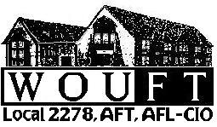
Western Oregon University Federation of Teachers
Local 2278, AFT, AFL-CIO
Western Oregon University, Monmouth, OR 97361

Representing WOU Faculty since 1974

Kent Neely, Provost
Western Oregon University
RE: Online SIR Instrument

Dear Provost Neely,

Following an agreement between the Faculty Senate and WOUFT to form a joint committee to examine and assess the proposed online course and instructor evaluation (see attached), the WOUFT Executive Board has voted unanimously to recommend delay of implementation of any new online course evaluation instrument until Spring Term 2010. We believe that delaying implementation until spring will allow the committee sufficient time to consider the proposed instrument and make recommendations in the interests of creating a WOU-specific course and instructor evaluation instrument that effectively meets the needs of students, faculty, and administration. As has been past practice at WOU, faculty members who wish to have their winter term courses evaluated could make arrangements with their division chairs or administrative assistants to do so.

We appreciate your consideration of this recommendation and welcome your comments and questions.

Sincerely,

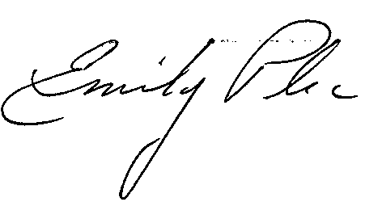
Dr. Emily Plec
WOUFT President
plece@wou.edu
503-838-8819

